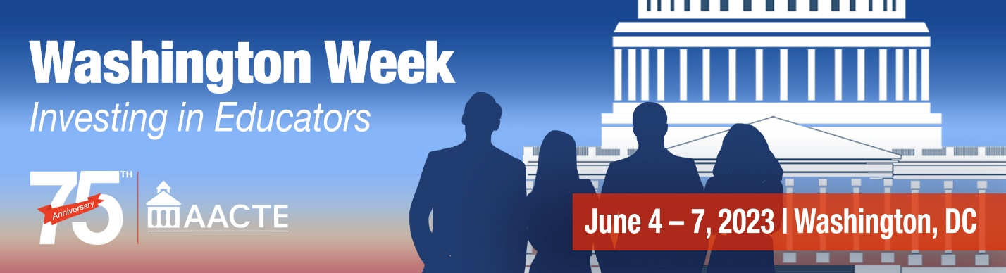

Augustus F. Hawkins Centers of Excellence Program
The Augustus F. Hawkins Centers of Excellence Program (Hawkins Program) supports comprehensive, high-quality teacher preparation programs at Historically Black Colleges and Universities (HBCUs), Tribally Controlled Colleges and Universities (TCCUs), and Minority Serving Institutions (MSIs).
HBCUs, TCCUs, and MSIs are uniquely positioned to recruit, prepare, and place teachers who will provide culturally and linguistically responsive teaching in underserved schools. Grantees are selected based on their focus on key aspects of a high-quality teacher preparation pipeline, including evidence-based, comprehensive teacher preparation that emphasize classroom experience and mentorship.
Today’s teacher workforce does not reflect the demographics of the nation’s public school students. More than 50% of public school students are students of color, yet in 2017-18, the most recent year of available data, roughly 25% of teachers were teachers of color. And while English learners (ELs) are the fastest growing public school student demographic, comprising more than 10% of America’s enrollment, most states face a shortage of bilingual and multilingual teachers prepared and certified for language instruction or to teach ELs. These roles are critical for ensuring Americans can compete in the increasingly globalized economy, guaranteeing equal access to education opportunity for ELs, and creating a strong economy in which all Americans can thrive.
Grant(s) awarded under this program is for a period of up to four years.

Funding History (in millions)
FY 2020 | FY 2021 | FY 2022 | FY 2023 | AACTE Recommendation
$0 | $0 | $8 | $15 | $300

2023 GRANT RECIPIENTS
Grantee | State | Award | Project Summary
California State University Dominguez Hills | CA | $1,599,946 | Increase number of teachers of color credentialed through teacher training and bilingual programs, and increase wraparound supports to improve completion and retention of future educators.
Metropolitan State University | CO | $1,571,926 | Increase completion rates of traditionally underrepresented students by providing comprehensive support for current and prospective students.
Florida International University | FL | $1,565,498 | Create four teacher preparation tracks, including a cohort of paraprofessionals already in partnering districts, two cohorts of English speakers, two cohorts bilingual Spanish/English speakers, and two cohorts of bilingual Haitian Creole/English. The program will reduce the barriers that typically affect enrollment in teacher preparation programs, including paid teaching experiences, test preparation, and dedicated advising.
University of Hawaii | HI | $1,592,314 | Expand existing special educator training to increase and retain more bilingual/multilingual teachers of color to serve students in the rural and remote areas across Hawaii.
National Louis University | IL | $1,341,279 | Implement three multi-pathway residency programs designed specifically to increase the access, participation and success of diverse and multilingual school paraprofessionals by incorporating culturally responsive teaching and learning standards, an evidence-based learning community, and multilingual supports for academic and licensure success.
Bowie State University | MD | $1,589,014 | Recruit and prepare black male educators in early childhood/special education, elementary, or secondary education who can provide effective, culturally relevant/responsive instruction and work with minoritized students and families
William Paterson University of New Jersey | NJ | $1,599,999 | Provide support to school districts throughout the area near Wayne, NJ, to focus on reducing barriers in teacher recruitment, placing teacher candidates in high need areas, and support high need areas through university-district partnerships. The long-term goal is to replicate these practices in school districts around the state.
Medgar Evers College of the City of New York | NY | $1,599,738 | Increase the number of teachers of color with career paths in high needs neighborhoods in Brooklyn, the number of bilingual teachers of color to serve a diverse student body, and teacher effectiveness.
Northeastern State University | OK | $1,512,832 | Provide support for the needs of teachers and teacher candidates on tribal land in the surrounding area and region, so there is one common place to find assistance such as scholarships and professional development.
University of Texas El Paso | TX | $1,586,079 | Recruit and train teachers, focusing on Latino teacher recruitment, in high-need certifications such as bilingual and special education.
University of Houston Clear Lake | TX | $1,599,669 | The project this grant will support is the STEM4ALL program supporting the recruitment, retention, and support for 30 new preservice students, who will become educators in STEM.
Sam Houston State University | TX | $1,599,900 | The grant will enhance the services of an existing program between a University Teacher Preparation Program (TPP) and a consortium of high-needs school districts.
TOTAL |  | $18,758,194

For more information: www.aacte.org or mrose@aacte.org

