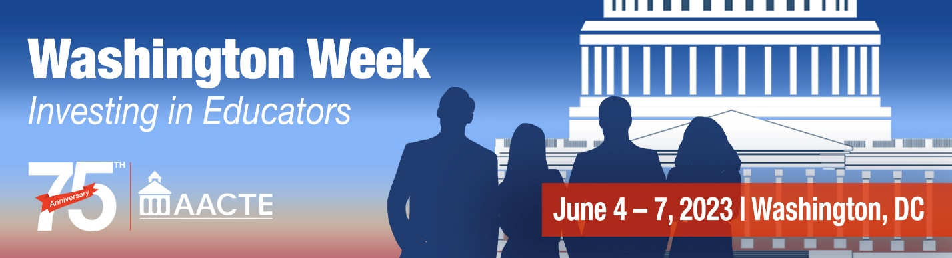

Teacher Quality Partnership (TQP) Grants

This grant program is the only federal initiative directed to transforming and strengthening higher education-based teacher preparation programs.

The Teacher Quality Partnership (TQP) program supports the preparation of profession-ready teachers for high-need schools and subject areas. Under this program, teacher preparation programs use federal funding to transform undergraduate preservice teacher and school leader preparation programs or to develop master’s-level teaching residency programs.

Program Highlights

- Grantees are partnerships among institutions of higher education, high-need local education agencies, high-need schools, or other eligible entities that work together to develop a pipeline of profession-ready teachers.
- Grantees are required to provide extensive, year-long clinical preparation to teacher candidates.
- Grantees must provide an induction program for at least the first two years of a graduate’s teaching career.
- Candidates participating in teaching residency programs commit to teaching for at least three years in a high-need field in the high-need district where they were prepared.
- All candidates are prepared to teach students with disabilities, to teach English language learners, and to teach literacy strategies.
- Grantees are expected to maintain the reforms even after funding ends, and they must provide a 100% funding match.

Funding Background

- This program received bipartisan support and was initially authorized at $300 million in Title II of the Higher Education Opportunity Act of 2008.
- Funding for this program, though, has never surpassed $50 million through the appropriations process, with the exception of $100 million dedicated to the program in 2010 through ARRA funds and Fiscal Year 2021.
- In May 2014, the U.S. Department of Education announced $35 million in new awards for FY14 with an emphasis on promoting STEM education.
- In September 2016, the U.S. Department of Education announced $5 million in new awards for FY16 with a focus on programs serving rural areas.
- In September 2018, the U.S. Department of Education announced $10 million in new awards for FY18 with a focus on STEM and novice grantees.
- Funding for Fiscal Year 2022 was $59 million, a $7 million increase over Fiscal Year 2021.

What Results Have TQP Grants Produced?

- Schools and school districts involved in TQP are seeing improvements in the quality and retention of their teachers and in the quality of their students’ learning experiences and achievements.
- TQP grants have funded significant professional development opportunities for teachers in high-need schools, meaningful induction/mentoring programs for novice teachers, and the implementation of evidence-based reforms in teacher preparation programs.
- Teacher preparation programs at institutions of higher education have deepened their partnerships with their PK-12 colleagues and the communities that they serve.
Funding History (in millions)
2021 | 2022 | 2023 | AACTE Recommendation
$52.09 | $59.09 | $70 | $1 Billion

FY 2020 Grantees*
Year awarded | Grantee | Duration (Years) | Year Award 1+ Frontload Award | Total Expected Funding | City
2022 | Board of Education City of Chicago | 5 | $1,132,557 | $4,207,764 | Chicago
2022 | Coppin State University | 5 | $1,107,998 | $4,111,319 | Baltimore
2022 | Frostburg State University | 5 | $827,708 | $3,587,710 | Frostburg
2022 | University of Texas at El Paso | 5 | $546,928 | $1,801,659 | El Paso
2022 | University of South Carolina | 5 | $1,151,454 | $5,110,596 | Columbia
2022 | Georgia Gwinnett College | 5 | $358,595 | $4,139,286 | Lawrenceville
2022 | Southeastern Louisiana University | 5 | $904,709 | $4,699,780 | Hammond
2022 | University of Colorado Denver | 5 | $1,584,442 | $6,865,070 | Denver
2022 | Reach Institute for School Leadership, dba Reach University | 5 | $1,353,196 | $8,737,238 | Oakland
2022 | Columbia College | 5 | $588,692 | $3,475,435 | Columbia
2022 | Winston Salem State University | 5 | $713,002 | $5,159,666 | Winston Salem
2022 | University of Cincinnati | 5 | $673,912 | $2,273,615 | Cincinnati
2022 | DePaul University | 5 | $1,370,041 | $5,369,855 | Chicago
2022 | National University | 5 | $1,195,778 | $6,508,149 | San Diego
2022 | UNC Charlotte | 5 | $559,406 | $2,206,380 | Charlotte
2022 | Center for Strategic Leadership and Organizational Coherence | 5 | $1,999,201 | $9,951,818 | Cambridge
2022 | University of North Florida | 5 | $1,011,537 | $7,023,252 | Jacksonville
2022 | High Point University | 5 | $2,369,120 | $9,786,041 | High Point
2022 | East Carolina University | 5 | $871,815 | $4,865,815 | Greenville
2022 | Three Rivers Education Foundation | 5 | $2,155,388 | $9,471,368 | Farmington
2022 | Prairie View A&M University | 5 | $721,863 | $6,152,432 | Prairie View
2022 | Alder Graduate School | 5 | $1,318,254 | $7,199,921 | Redwood City

*Most recent year available

For more information: www.aacte.org or mrose@aacte.org

