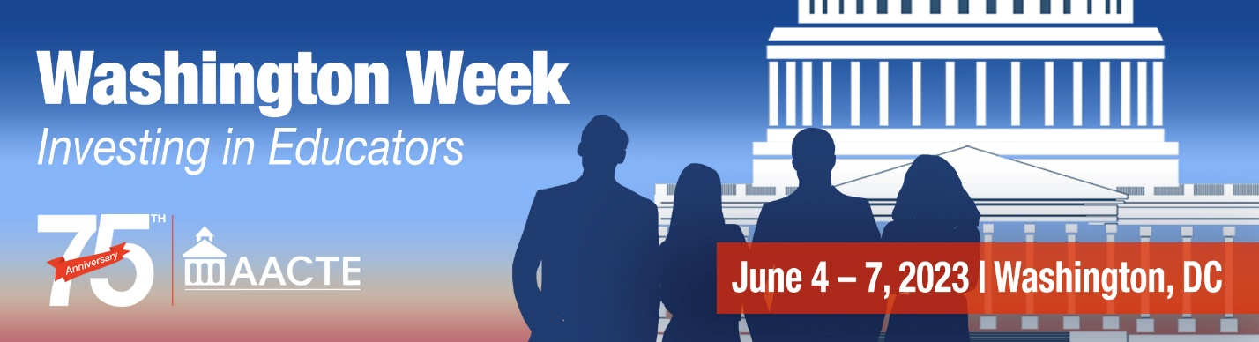
118th Congress Legislative Priorities

FY 2024 Appropriations
To prepare a diverse, profession-ready educator workforce and address educator shortage areas, AACTE is advocating for the following program funding levels for FY24:
- Teacher Quality Partnership Grants at $1billion
- Augustus F. Hawkins Centers of Excellence Program at $300 million
- Special Education Personnel Preparation at $300 million
- $3 billion for Title II of the Elementary and Secondary Education Act to support The Supporting Effective Instruction program
- $73 million for the American History and Civics Education program
- $335 million for the Department of Labor’s Registered Apprenticeship Program

Endorsed Legislation
AACTE supports robust improvements to the Higher Education Act with multiple provisions to recruit and retain candidates to become skilled educators. Reauthorization of the Higher Education Act may not occur for some time, but there are several pieces of legislation currently introduced that would strengthen educator preparation and the educator workforce. AACTE strongly supports the following bills:

EDUCATORS for America Act
- Authorizes $500 million annually for grants to support states in developing and implementing a statewide strategy for meeting educator workforce needs; including ensuring an inclusive and equitable workforce that supports the recruitment, preparation, and retention of teachers of color, teachers from low-income and first-generation families, and teachers with disabilities.
- Authorizes $500 million annually to support educator preparation programs and partnerships, including updating and expanding the Teacher Quality Partnership grant program to focus on residency programs, strengthen principal and school leader preparation, and enable partnerships to address the need for early childhood educators, school librarians, counselors, and other specialized support personnel.
- Removes financial barriers to entering the education profession by:
  - Doubling TEACH grants to $8,000 per year and providing additional protections and options to prevent the conversion of grants to loans.
  - Strengthening three critical loan forgiveness programs utilized by teachers: Public Service Loan Forgiveness, Teacher Loan Forgiveness, and Loan Forgiveness for Service in Areas of National Need.
- Calls for the National Center for Education Statistics to convene an expert panel to make recommendations on a robust and concise set of national indicators on the size, diversity, and quality of the teacher workforce.

Diversify Act
  - Ends annual cuts to the TEACH Grant award, which this year resulted in a decrease to the maximum award of more than $225. Without Congressional action, these cuts will continue through 2029.
  - Requires the Secretary of Education to send TEACH Grant recipients who have completed their service an electronic certification noting this accomplishment.
  - Supports early childhood educators by ensuring that they are eligible for TEACH Grants by including service in a high-need early education program as an eligible service area and adding early childhood education as a codified shortage subject.
  - Ensures that only educator preparation programs at public and private non-profit institutions of higher education are eligible to participate in the TEACH Grant program.

Pay Teachers Act
Significantly increases federal investments in public schools and in supporting the teaching and school leader professions.
- Diversifies and expands the teacher pipeline by: (1) authorizing a new Grow Your Own program within the Teacher Quality Partnership (TQP) grant program and providing $550 million for TQP grants; (2) investing $150 million in the Augustus F. Hawkins Centers of Excellence program to support teacher preparation at HBCUs, TCUs and other minority-serving institutions; and (3) investing $300 million in IDEA, Part D to support the special education personnel pipeline.
- Supports states in increasing teacher salaries, including by improving resource equity.
- Requires states to establish a minimum salary for teachers of at least $60,000.

The Loan Forgiveness for Educators Act
Reforms the Teacher Loan Forgiveness (TLF) Program:
- Incentivizes educators to work in early education programs and high need public schools by having the federal government make educators’ monthly student loan payments during service and providing complete forgiveness of student loan debt at the end of five years of service;
- Expands program eligibility to include early childhood educators and program directors and administrators in high need public schools and changes the program name to Educator Loan Forgiveness (ELF);
- Ensures that educators retain loan repayment and forgiveness benefits if the status of their school changes to no longer be high need or if they take on additional responsibilities while they are serving. Educators will still be able to make progress toward loan forgiveness if they have to take off for Family Medical Leave Act (FMLA), military service, or are impacted by a national emergency.

