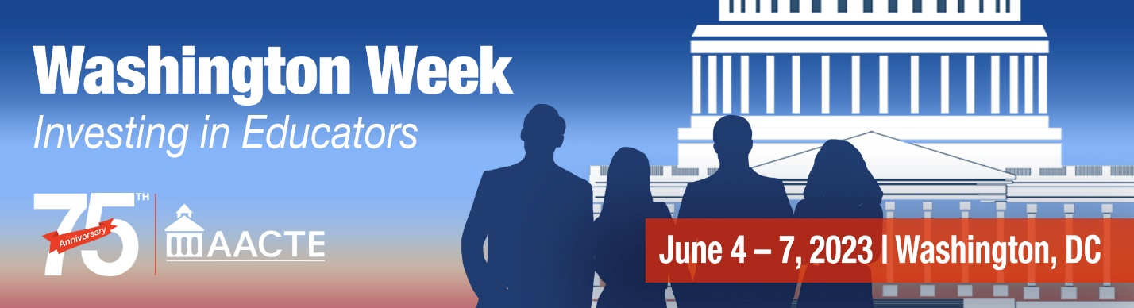

Special Education Personnel Preparation Program Fact Sheet

Improving Services and Results for Children with Disabilities

The special education personnel preparation program is designed to ensure that children with disabilities are supported by fully certified school personnel. Competitive grants provide research-based training and professional development to help states meet identified needs for fully certified personnel. A significant portion of the grants go to institutions of higher education to support training for special education, general education, and specialized instructional personnel to ensure that all personnel have the skills and knowledge needed to serve students with disabilities.

The program, authorized through the Individuals with Disabilities Education Act, Part D Sec. 622 (20 U.S.C. 1462 and 1481), features several required high-priority areas, including beginning special educators, personnel to serve children with low incidence disabilities, and leadership personnel. Grants require incorporation of best practices as determined through research, evaluations, and experience.

Pathways to meeting the required priorities include partnering with states and LEAs to ensure teachers are profession ready as they enter the classroom; addressing inequities in the distribution of effective teachers; and alleviation of ongoing personnel shortages of teachers and leaders who are prepared to provide evidence-based services for children with disabilities.

In 2016, 1,593 scholars completed programs; 73% of grants funds were used for monetary support for scholars in programs where scholar stipends are authorized with 88% of enrolled students receiving an average of $11,558 per scholar.

Program performance information indicates that 95% of grants incorporate scientifically or evidence-based practices; that only 1% of scholars exit training programs prior to completion due to poor academic performance; and that 93% of degree/certification recipients work in the area(s) for which they were trained.

As of May 2023, there were more than 400 current grants in states throughout the country and the District of Columbia.¹

Funding History (in millions)
2020 | 2021 | 2022 | 2023 | AACTE Recommendation
$89.7 | $90 | $95 | $115 | $300M

¹ For more information on the grants visit: https://www2.ed.gov/programs/osepprep/awards.html

For more information: www.aacte.org or mrose@aacte.org

